Point of Sale Application

Café Sanchez v1 (.NET 6)

Case Study

Lars Nysom

[lany@ucn.dk](mailto:lany@ucn.dk)

UCN 2022

# Introduction

## Scenario

The purpose of this application is to keep track of customer orders and is designed in a way that supports the workflow in the café.

When a customer comes into the shop, she places an order for one or more beverages. The order is entered into the system with the customer’s name and is processed by the barista. When it is ready, the customer’s name is called and she steps up to the counter, pays, and get the beverages.

The system can keep track of several orders simultaneously, but do not keep records of the sales. When an order is finished and paid for, it is deleted from the system.

## The Application

The application is a *desktop application* that is implemented with the three-tier architecture.

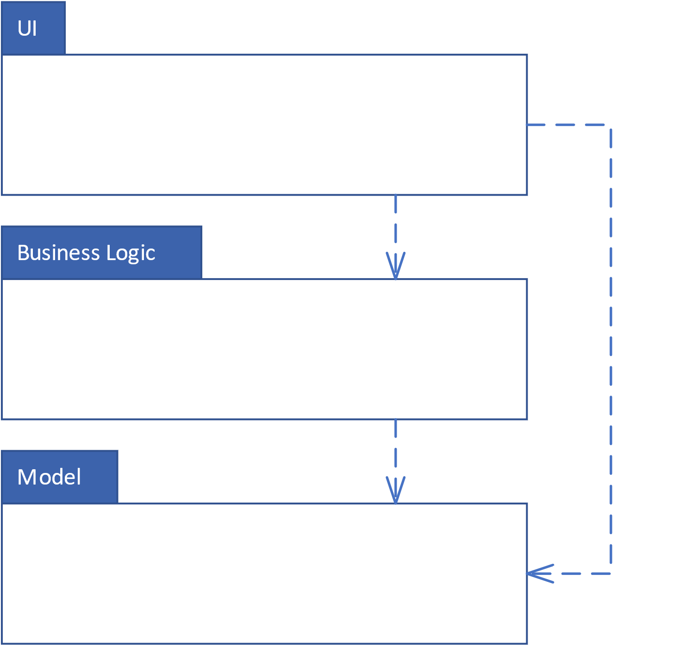

Figure 1: Three-tier open architecture

### UI

This layer is implemented as a desktop application that serves as a point-of-sale (POS) application. It is designed to satisfy the *OrderHandling* Use Case shown in Appendix A and consists of the two following screens.

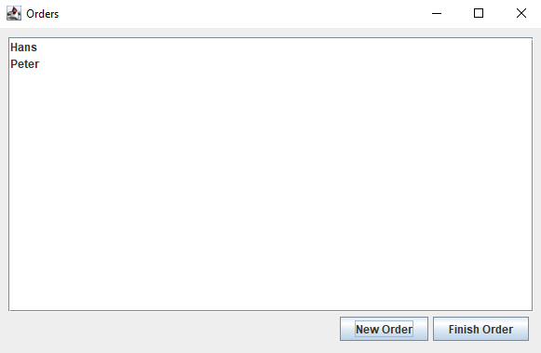

Figure 2: Main screen

Figure 3: Dialog for creating new orders

### Business Logic

### Model

## Technology Stack

# References

Coulouris, G., Dollimore, J., Kindberg, T. & Blair , G., 2012. *Distributed Systems.* 5th red. s.l.:Addison-Wesley.

Fielding, R. T., 2000. *Architectural Styles and the Design of Network-based Software Architectures,* Irvine: University of California.

Gupta, L., 2022. *What is Rest.* [Online]   
Available at: https://restfulapi.net/  
[Senest hentet eller vist den 18 05 2022].

## 

## Appendix A

**Use Case 1 – Order Handling**

|  |  |
| --- | --- |
| Scope | The Coffee Break POS |
| Level |  |
| Primary Actor | Barista |
| Stakeholders and Interests | Cashier:  Barista:  Customer:  Shop Owner: |
| Preconditions | Products are registered in the system |
| Success Guarantee | Customer order is processed and the correct price for the total order is calculated and settled. |
| Main Success Scenario | 1. Customer arrives at POS 2. Cashier starts a new sale by entering the customer’s name 3. Cashier selects the beverage and quantity the customer orders 4. System records beverage and quantity, calculates total price, and presents information on screen 5. Cashier repeats step 3-4 for every type of beverage the customer orders. 6. Customer pays and Barista produces order 7. Customer leaves with products |
| Extensions | 1. Power outage    1. Cashier restarts system |